Gratitude Tree
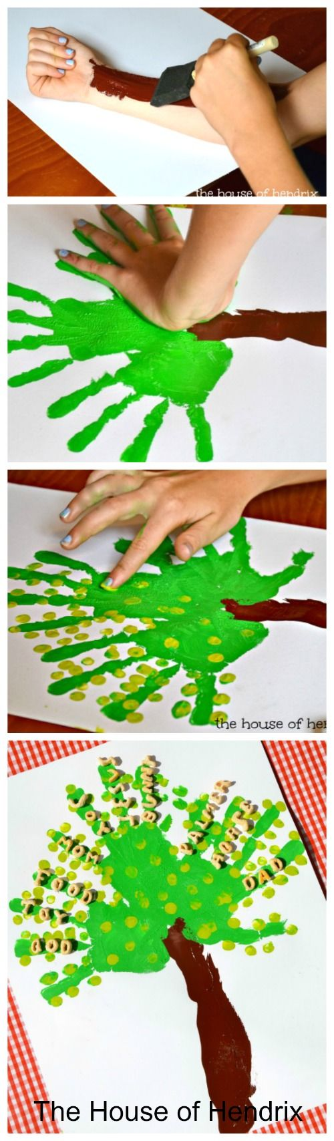
Begin by making the trunk of the tree with your forearm. We used brown paint on the outer side of your arm and then pressed onto paper. Character Lesson – Our bodies are like a trunk of a tree. The bark protects the good things the roots absorb while also keeping harmful things away. How can we use our bodies to nourish and also protect our hearts?
Make the leaves of the tree with green hand prints. We filled in a few gaps with a paintbrush. Character Lesson – We can use our hands to help others.
Use fingerprints to add some leaves to the branches. Character Lesson – Our fingerprints are unlike anybody else in the world. We are each made special and with purpose.
After the paint dries, spell out words of things that you are thankful for with the Alpha Bits cereal/letters/or write words onto the tree. Glue their words of thanks onto the branches of the tree. Character Lesson – Our words are a reflection of our hearts. Let’s use words of thanks and of encouragement for one another.

